PLASTIC OF WELLINGTON

Victoria University of Wellington Master of Fine Arts (CP) Final Project 2019

ARTIST BIO:

Through the medium of photography I am able to succinctly and clearly convey abstract concepts that I am unable otherwise to communicate orally or by written word. The lens of the camera affords me the opportunity to frame my ideas and, by way of this medium, to address critical issues that impact society and the environment. The camera instils the capacity for me to explore complex issues without the messiness of wordy explanations. My images function as a commentary on the way in which humankind treats the environment and the haphazard way in which we create, exploit, and destroy all that we encounter. The subjects that intrigue me are heavy in detail and vivid colours, as well as layered in meaning. The outcomes produced, images printed to paper or experienced digitally, aim to be simultaneously beautiful and provocative. I want viewers to leave the gallery with a better understanding of the journey our plastic takes once it leaves our hands. The goal of this body of work is to provoke identification with objects we use on a daily basis by distinguishing individual items from the monochrome mass of waste that we normally associate the issue of plastic with.

PROJECT CONCEPT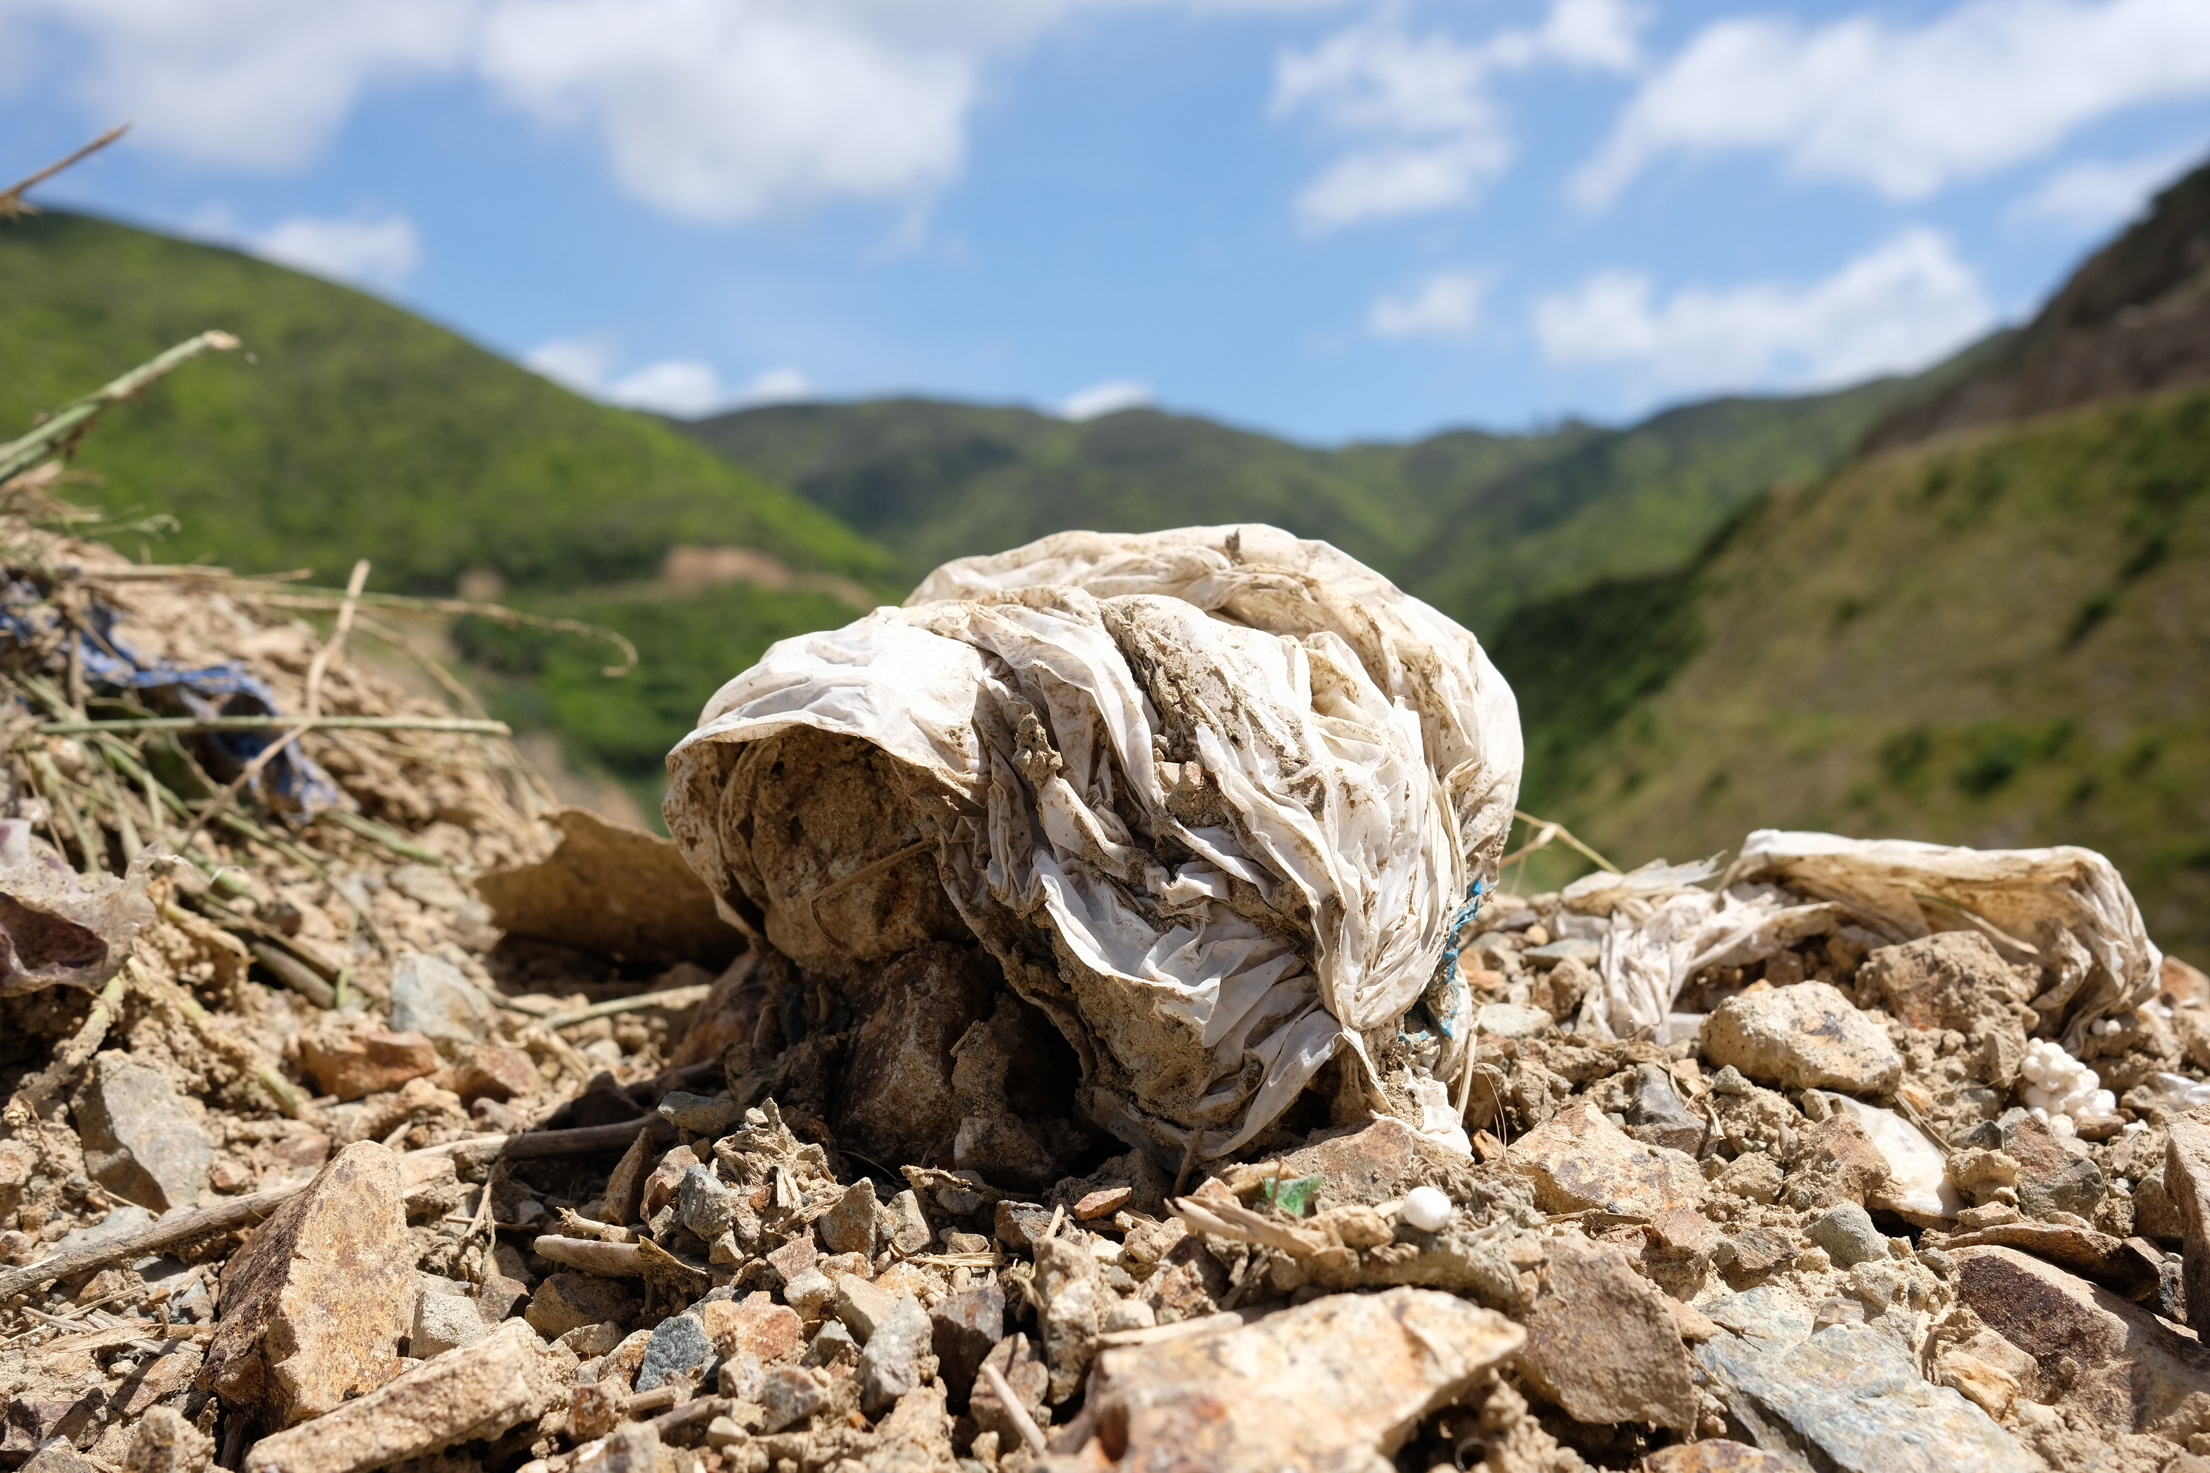

Single-use plastics are so common in our lives that we subconsciously assume they are mutually inclusive with our built environment. City streets littered with plastic wrappers is so commonplace that this waste is hardly given a thought. Through the medium of photography, the excess single-use plastic that litters and unnecessarily fills our environment is illuminated and re-contextualised. The images produced in this body of work aim to provoke empathy, awareness, and identification with the ongoing impacts of single-use plastics within Wellington City through a focus on three scales: individual, household, and community waste habits. Photography was selected as the ideal medium for this project as this issue of plastic waste is best shown rather than told. The result is a graphic examination of the linear path that plastic waste takes from our individual uses to the vast landfills and beyond. Through this work I hope to provide viewers with a simple story of Wellington’s waste habits and a better understanding of what happens to the plastic we use in our everyday lives

**THE GOAL:**This body of work was originally a part of the Convergence exhibition, the final exhibition for the 2018/19 MFA Creative Practice course. The goal of this installation is to give people a better idea of where their single-use plastic ends up once they are finished using it. I felt that a public display would be suitable for this body of work to confront all who walk past rather than only those who choose to go to a sustainability themed gallery.

LOCATIONS

This project, “Plastic of Wellington”, is made up of six series of photographs that collectively represent three scales of the plastic waste problem in the context of Wellington, New Zealand. I worked in three different environments for my final body of work; the city streets, the curbsides in the suburbs, and the council landfill.

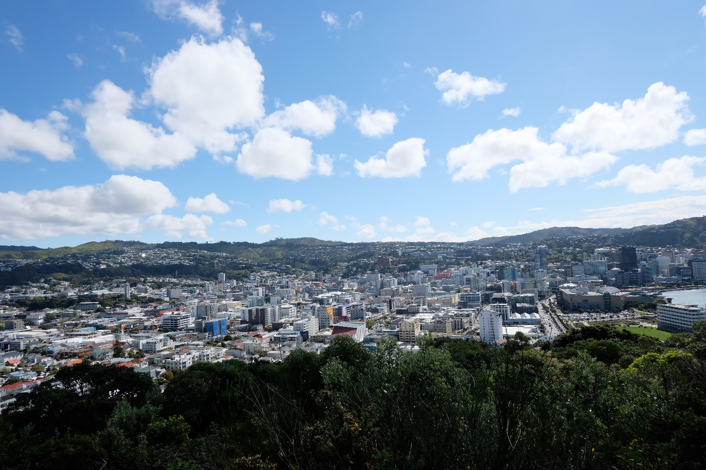

SERIES #1  INDIVIDUAL : STREET

Location: Wellington CBD  
Metro density: 300/km2

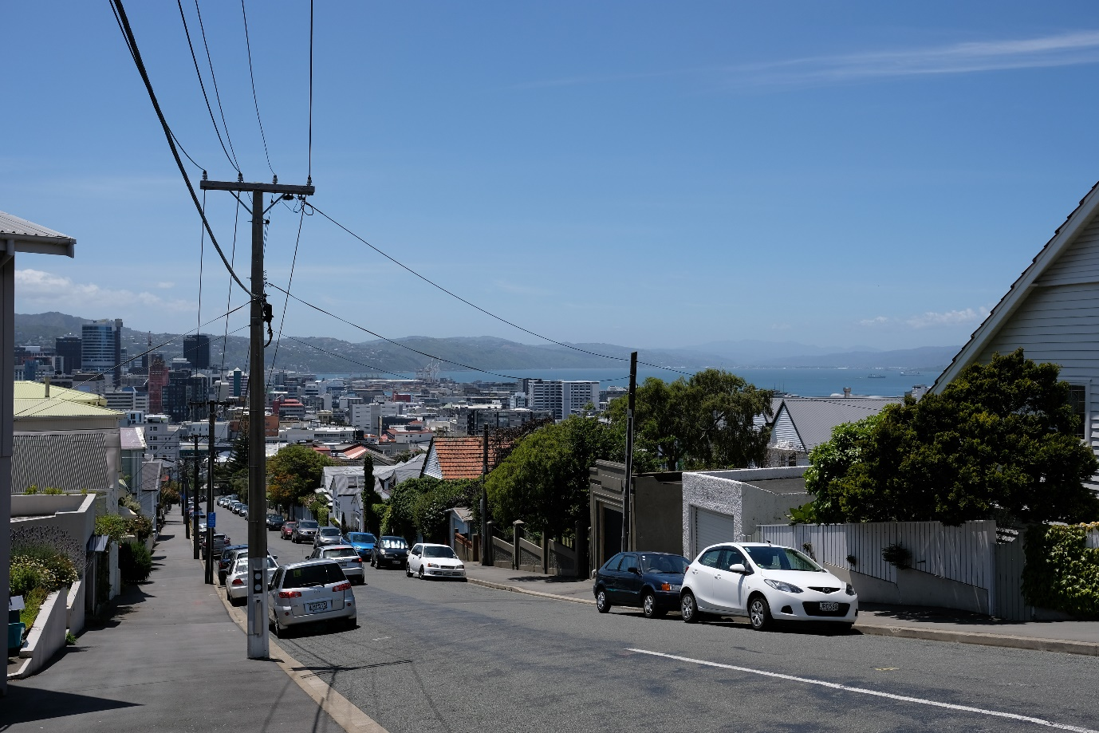

SERIES #2  HOUSEHOLD:  BAG

Location: Wellington suburbs   
Urban Population:     418,500

Suburbs used in this project: Te Aro, Kelburn, Mt Victoria, Aro Valley, Kilbirnie, Newtown & Thorndon.

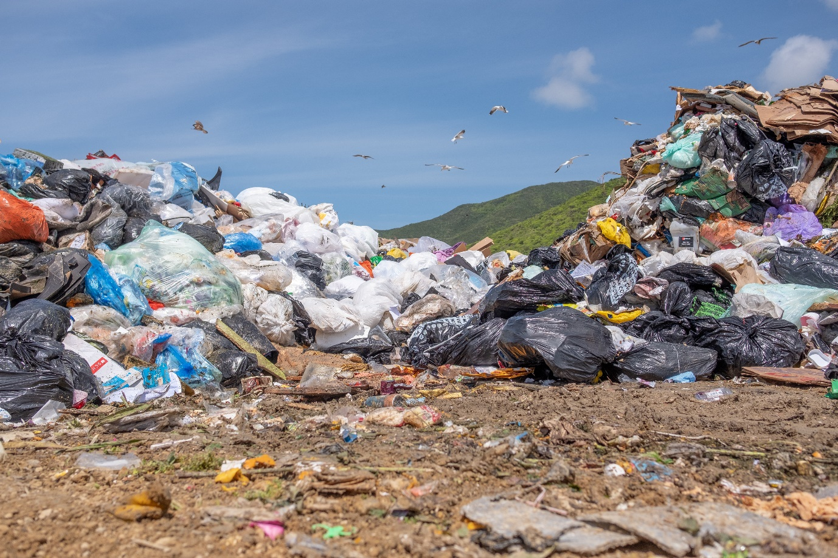

SERIES #3  INDIVIDUAL : DUMP

Location: Southern Valley Landfill,  
Landfill Rd, Owhiro Bay, Wellington 6023   
Distance from CBD: ~7km

SERIES #1 INDIVIDUAL: STREET

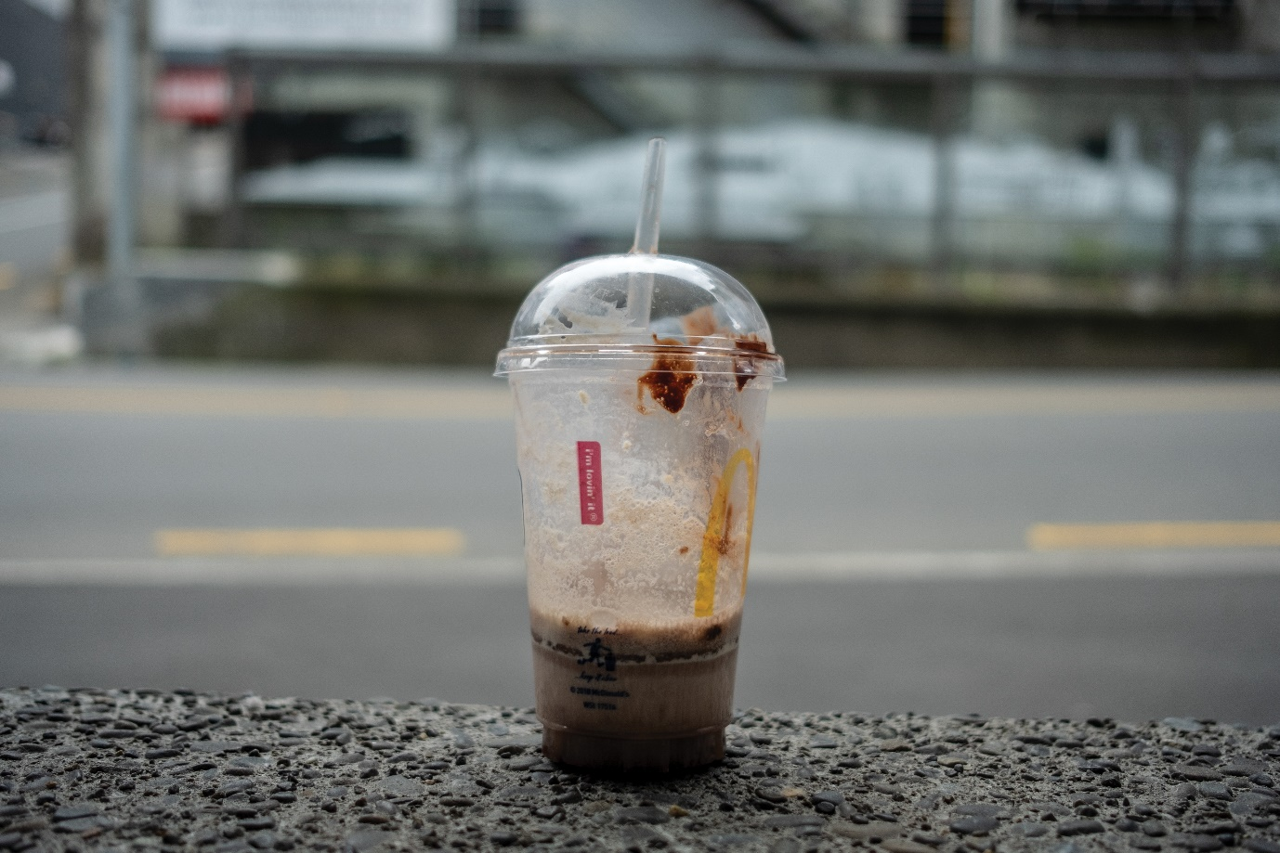

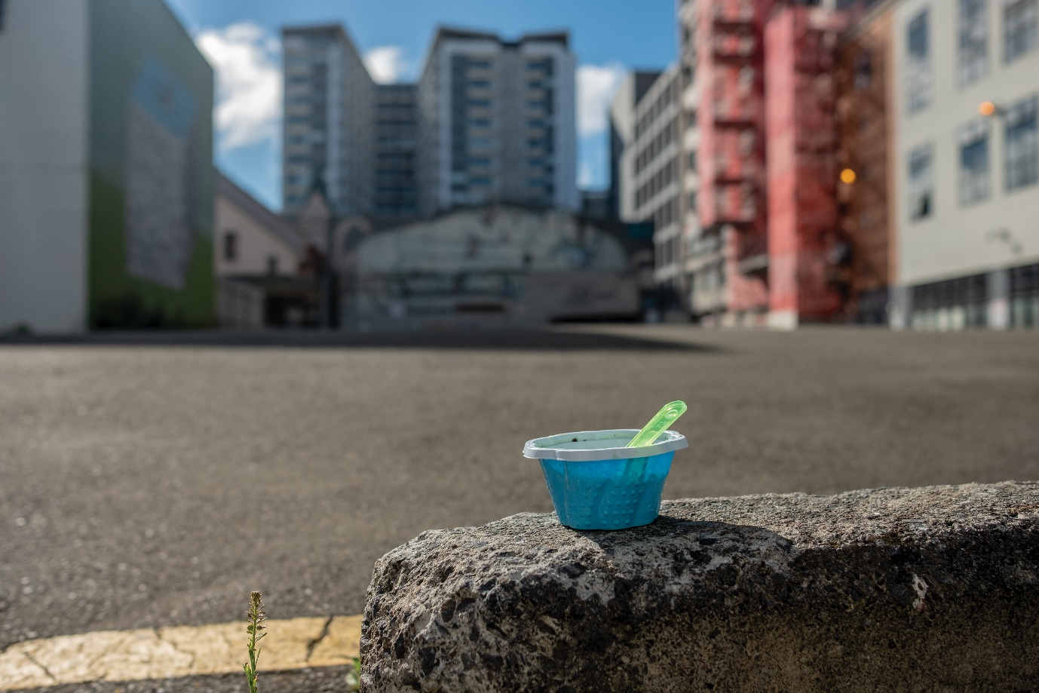

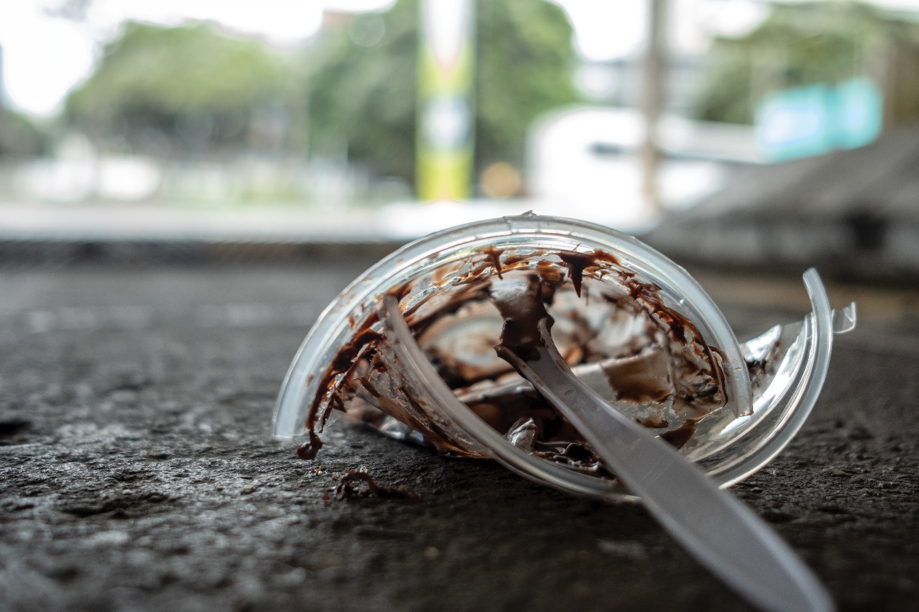

The first scale is a small, intimate series looking at individual pieces of plastic around the Wellington cityscape that dot our streets. This is the most obvious and blatant visual of the end of a piece of plastic’s usefulness and the beginning of its pollution of the environment. The photos are all food-based products because they are the most recognisable, they’re used by everyone and all have very specific functions. Shooting this series involved wandering around the street searching for pieces of plastic in the early hours of the morning before the streets had been swept. I wanted all of my pictures to be authentic and therefore did not stage any of these scenes. As a result of the Wellington Council’s rigorous street-sweeping routine, it was difficult to find subjects to shoot. Much akin to fishing, I could go hours or even days without taking a single photograph. Due to their difficulty to find, when I found the plastic items on the streets, I would generally take pictures from a variety of angles. Overall, it was important to keep the plastic in the centre of the frame and show enough of the background for the viewer to be able to identify the type of environment it is in.

Series #2 Household: Bag

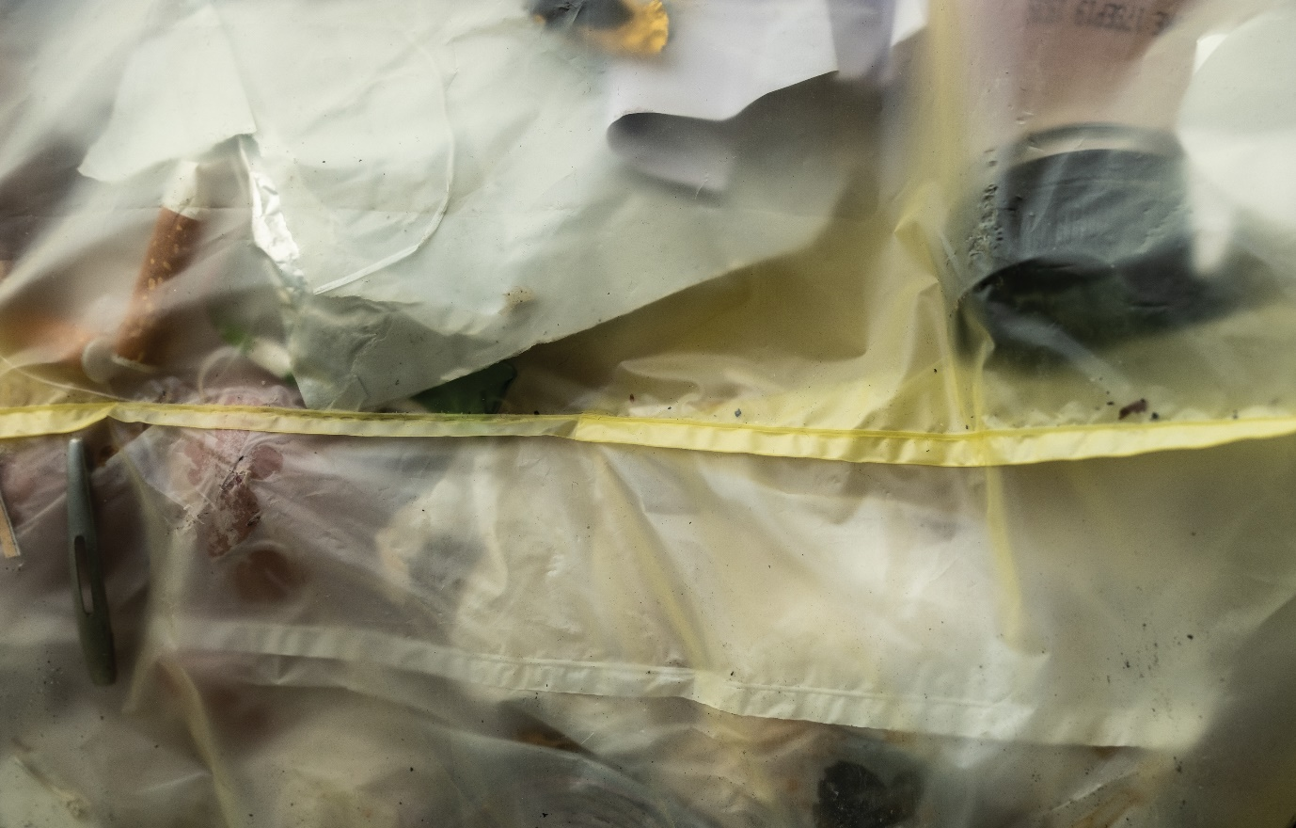

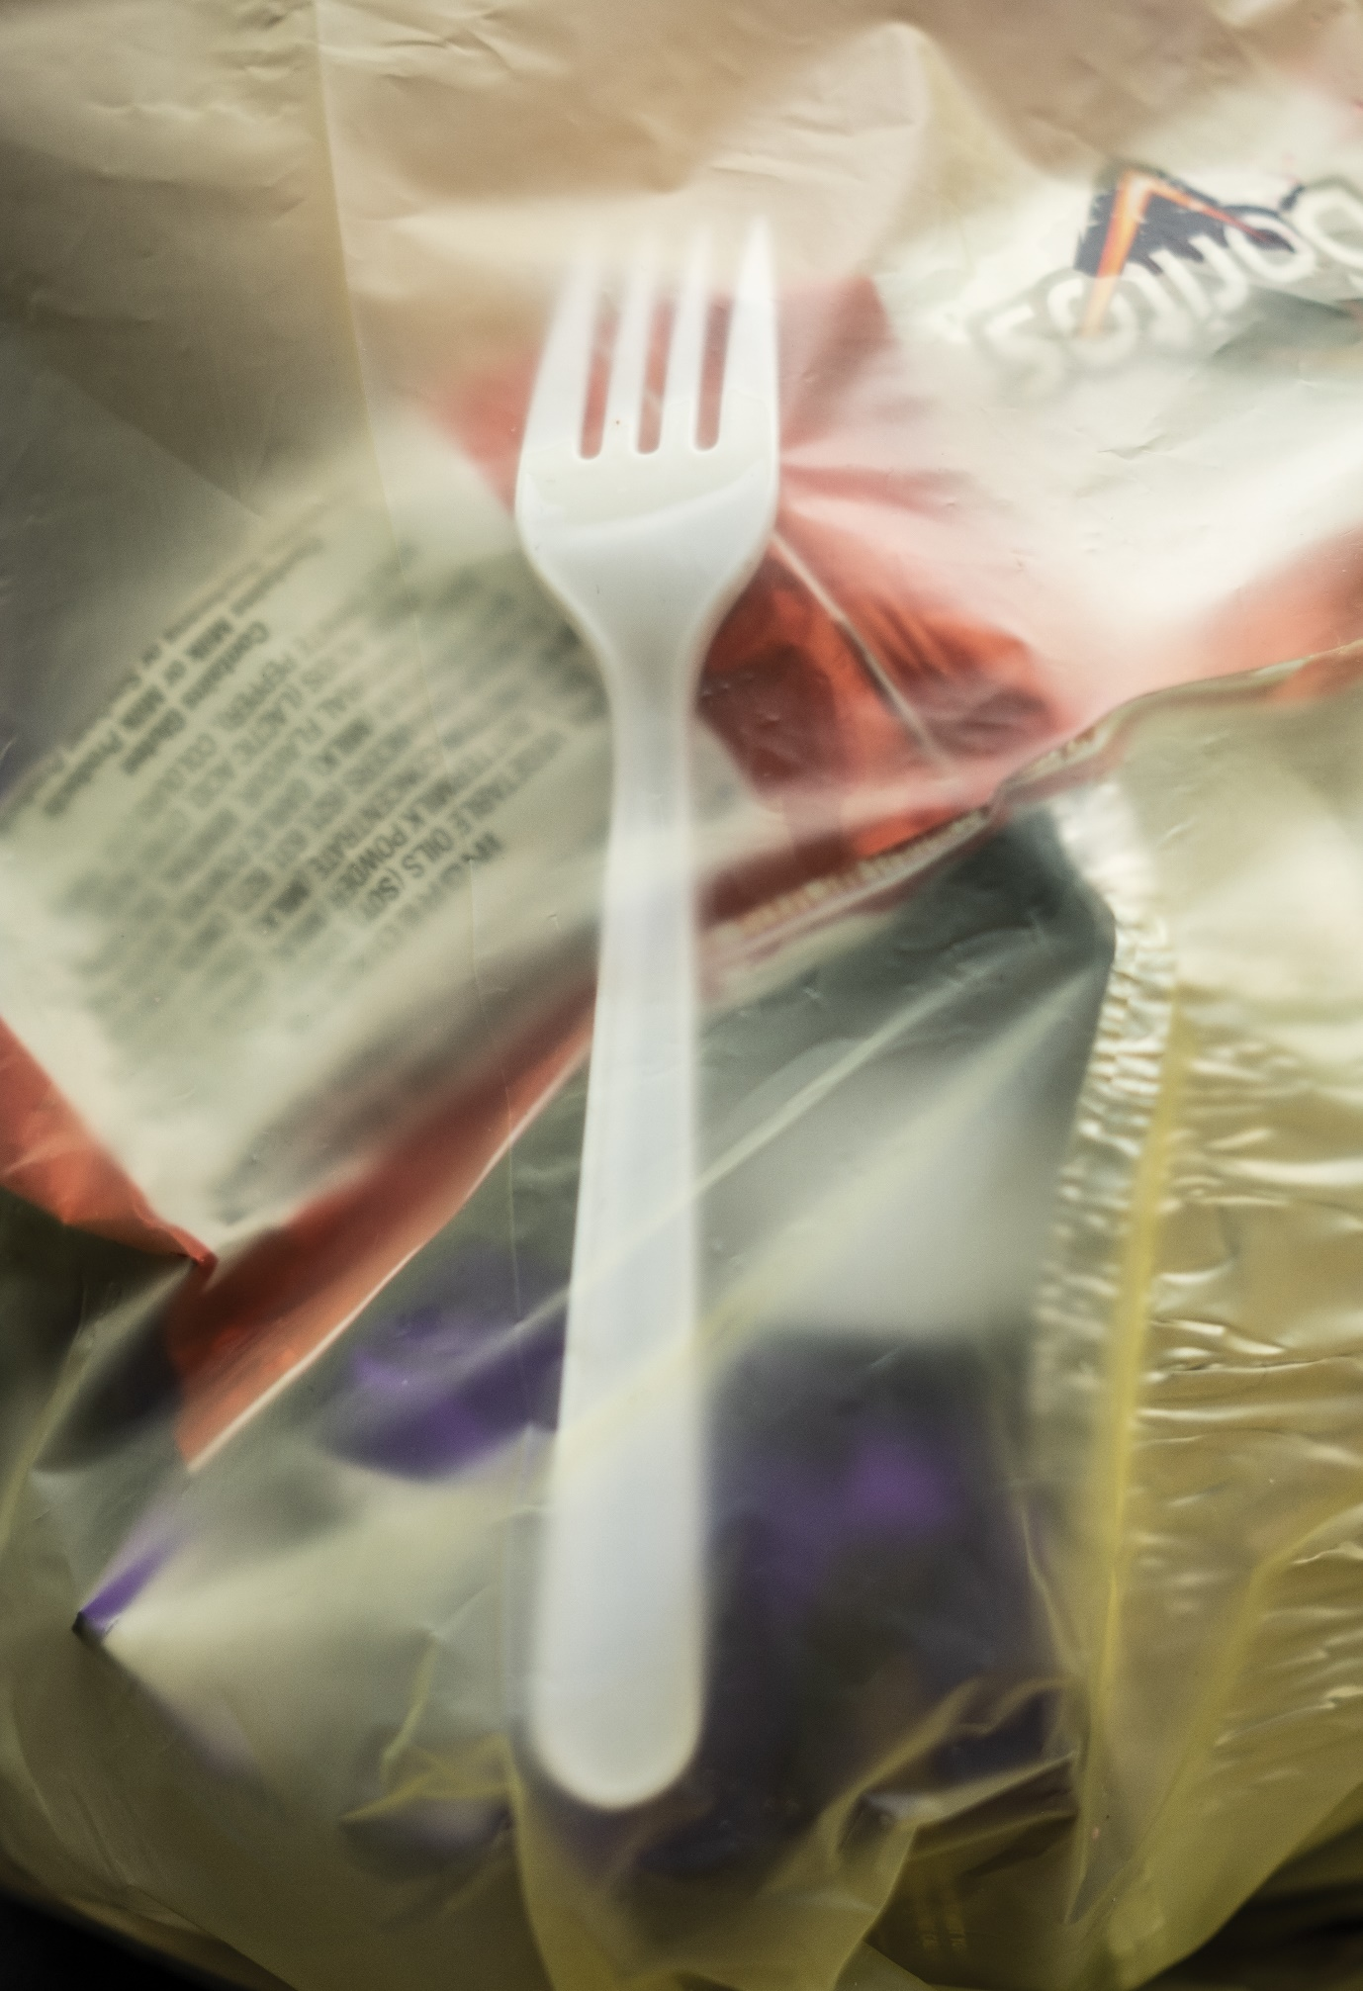

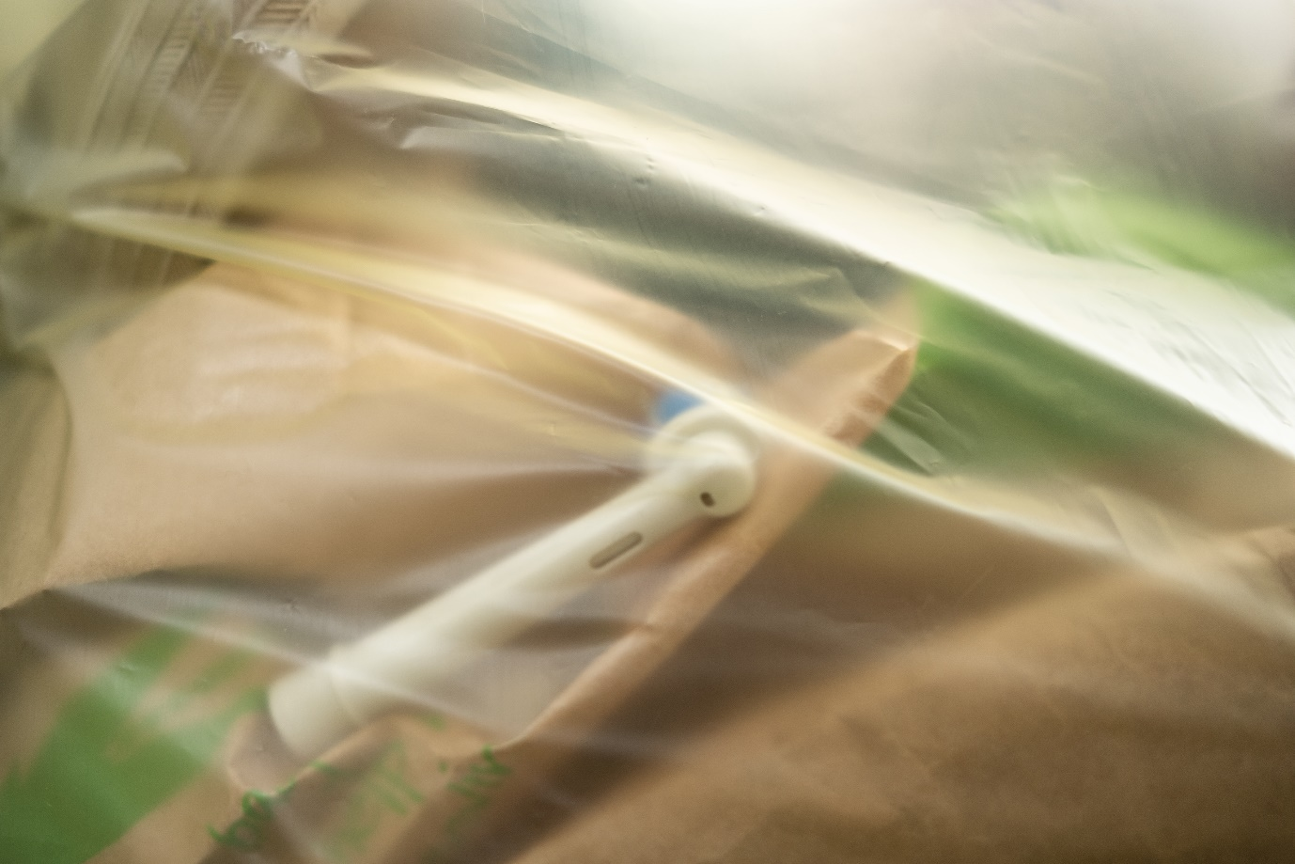

The second scale explored in this body of work confronts Wellingtonians about what they put in their rubbish bags. These are close up photos which look at identifiable items contained in council rubbish bags. These landfill bags often have largely recyclable contents. The bags that hold our rubbish are the Wellington colours; yellow and black. Given our perceived progressiveness, I feel like this shows a cockiness in Wellington that we are willing to use our city’s colours to hold our trash. One would assume that a sort of patriotism would come out in that we would be more careful about what we put in them, especially as they’re transparent. The bags are a gateway to the dump; they’re the interim between the individual pieces of plastic we use daily, and the unknown journey they take after the bags have left our curbside. The bags are the last time we see our rubbish, we don’t really know what happens to it after that. This was the easiest series to shoot as all I had to do was research when each suburb’s rubbish collection days were and be in the area earlier than the collection service. As a result, I was able to get a lot of pictures in a relatively short space of time. The biggest challenge was to find interesting assortments of plastic and textures within the council bags, which all look the same. This made it difficult to get a lot of variety between these pictures.

Series #3 Community

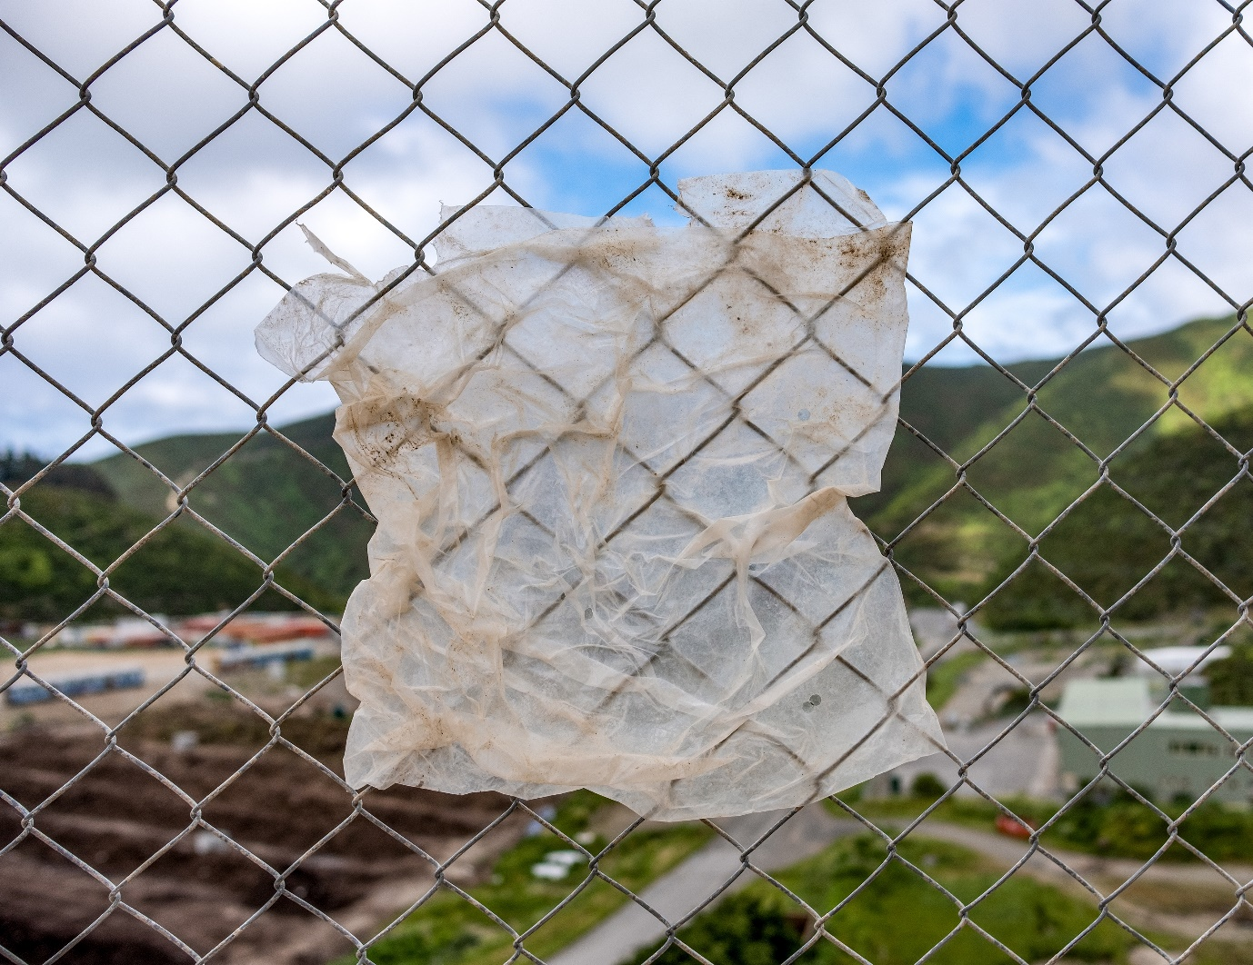

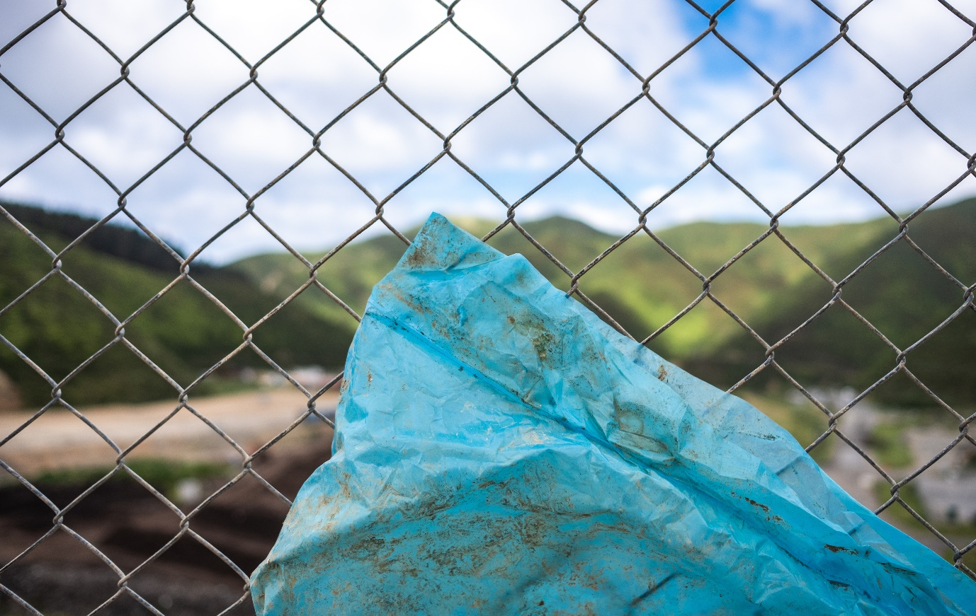

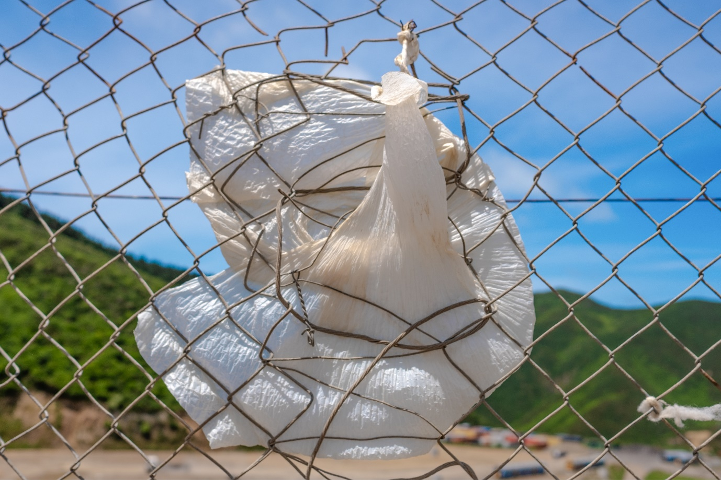

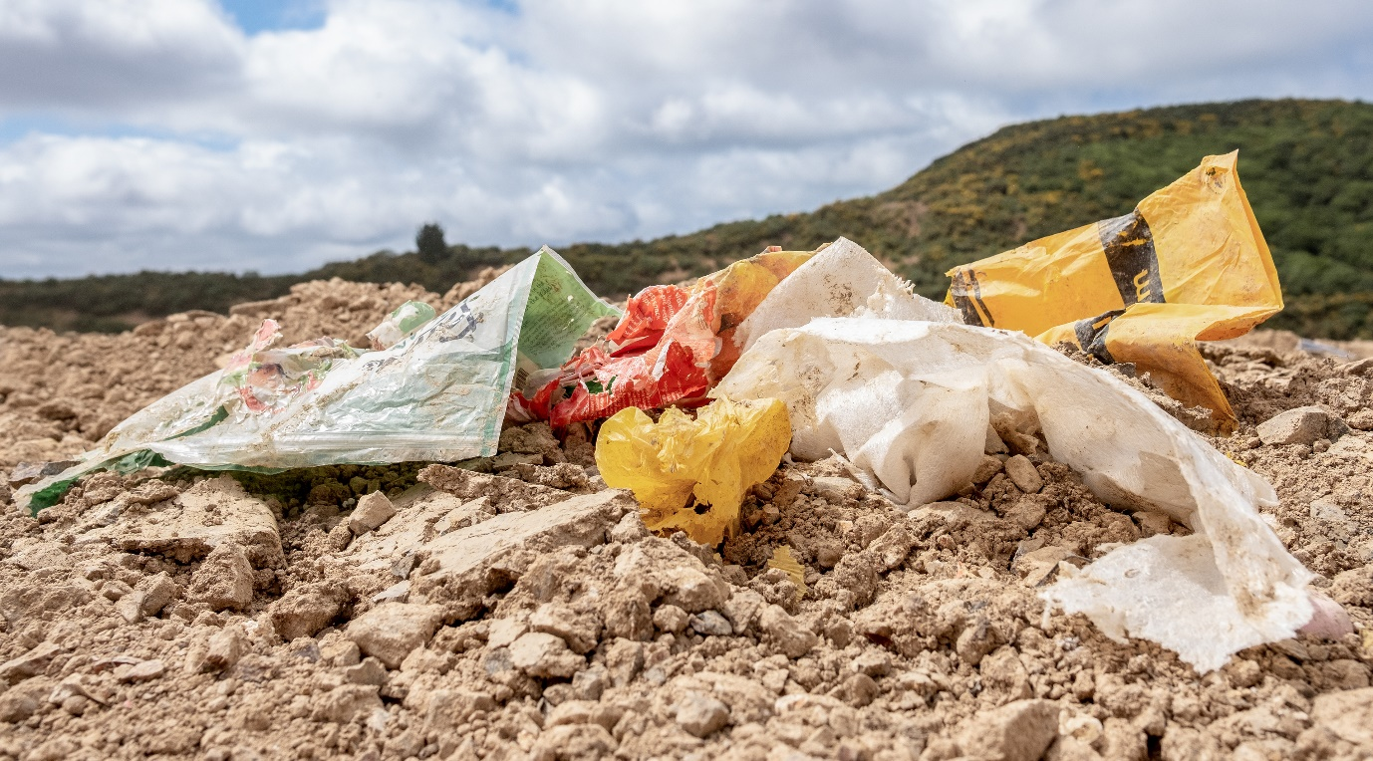

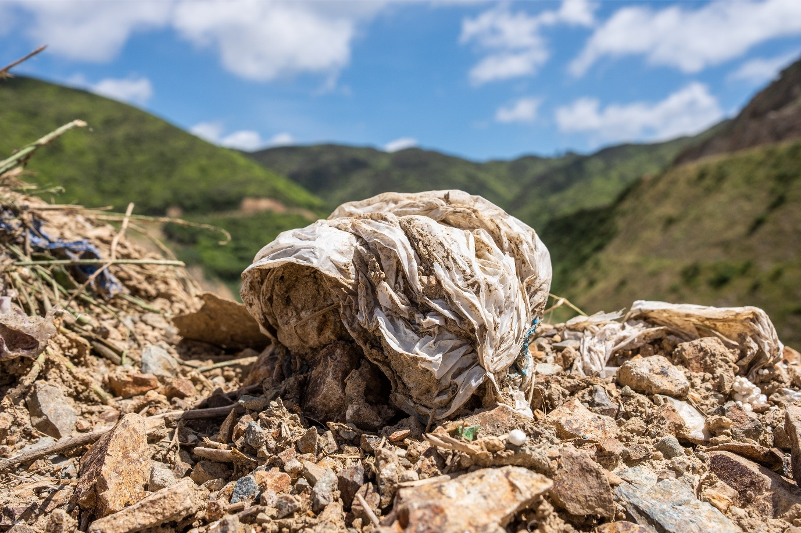

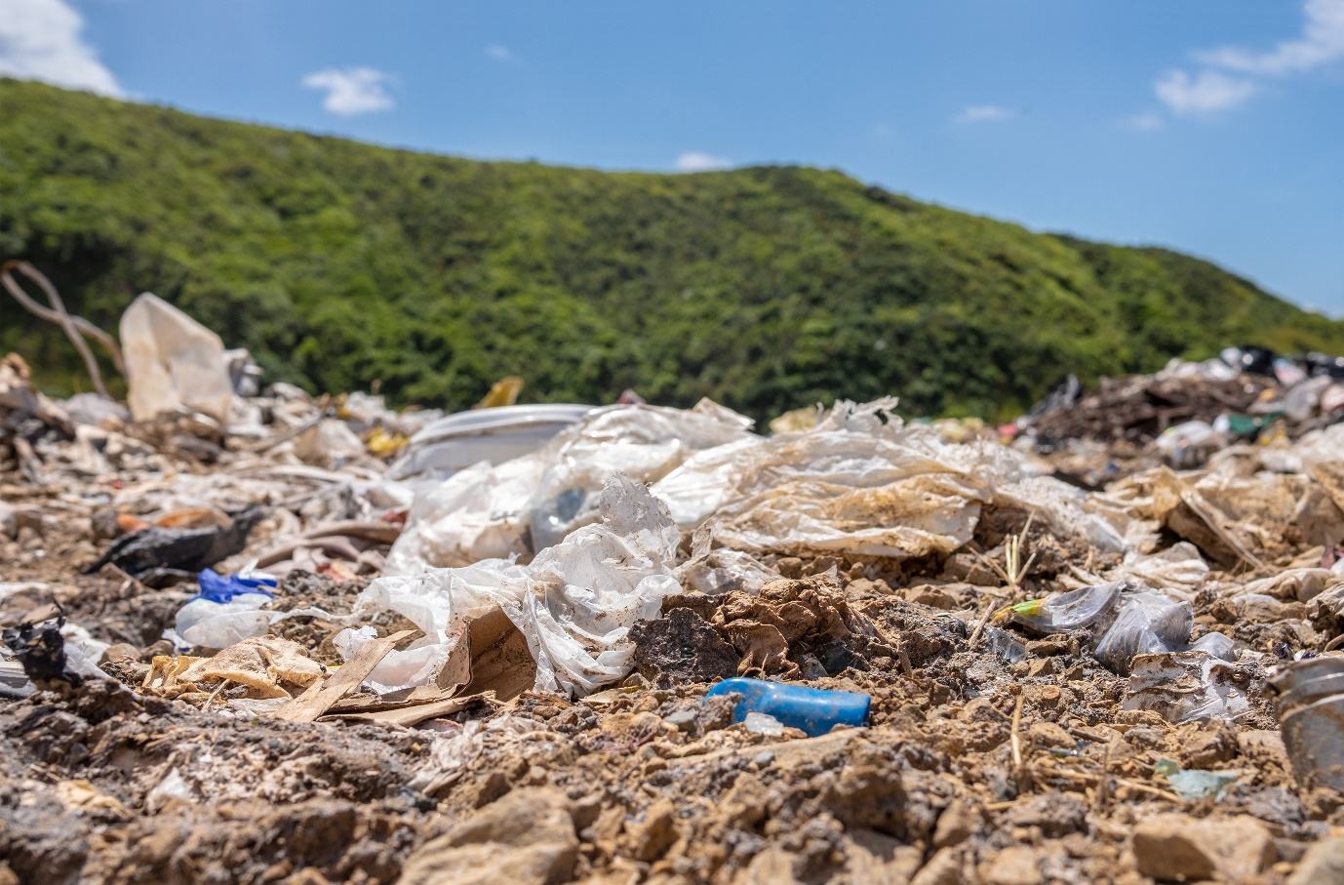

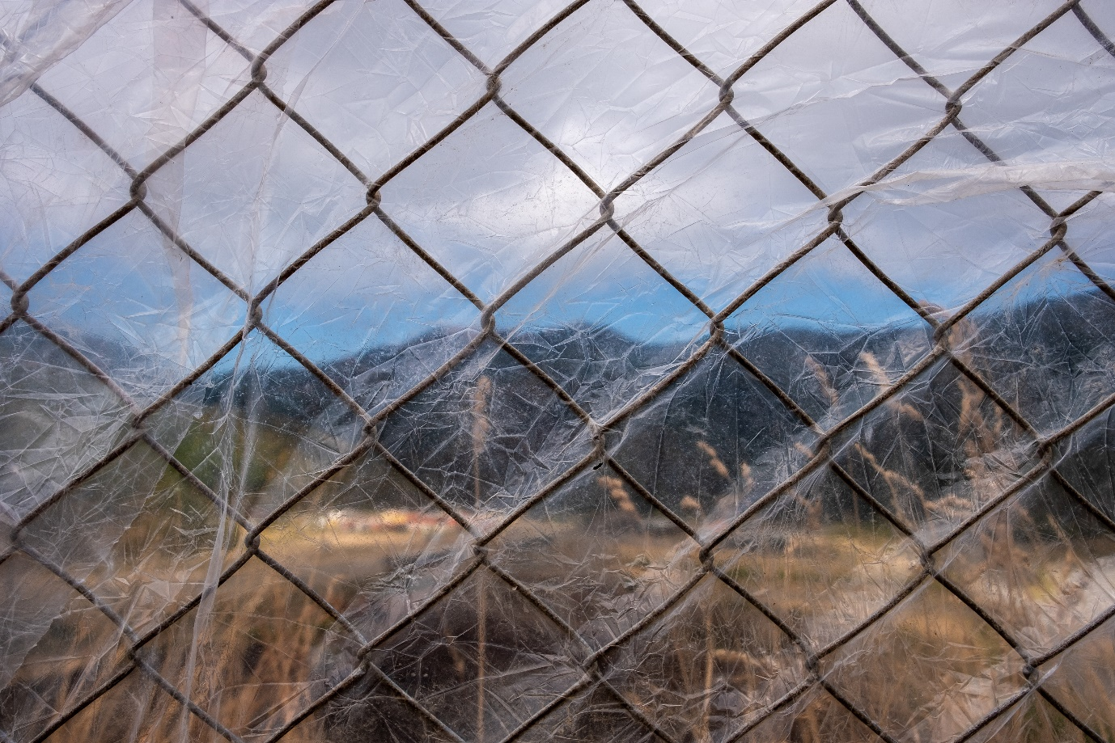

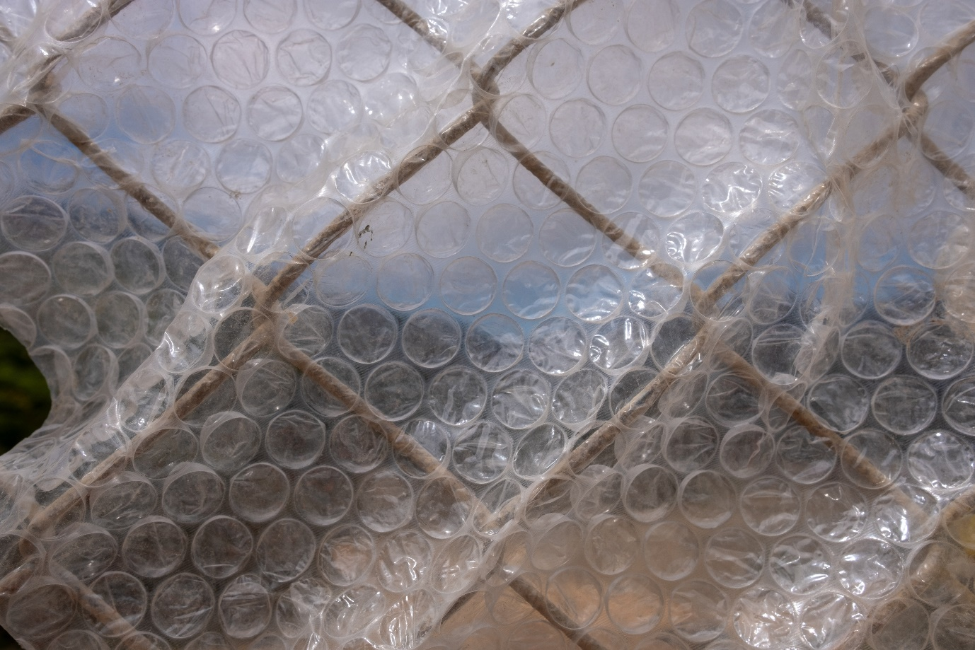

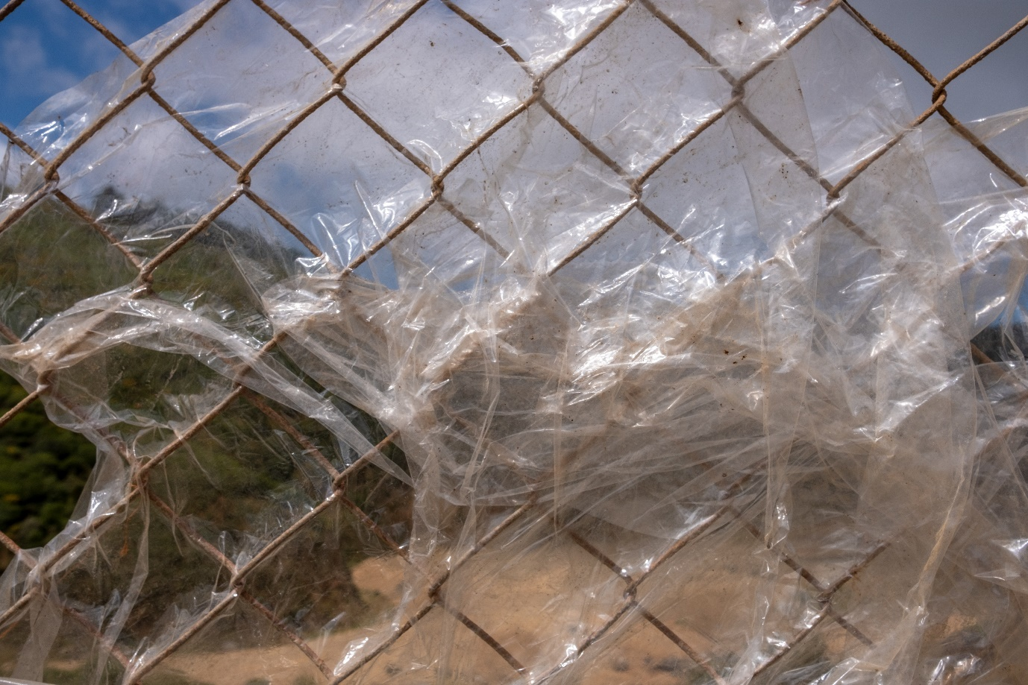

The third scale addresses the Wellington community at large. In this part, the scale changes dramatically from closeups to more wide shots. The idea behind these larger scale shots is that the stage in the lifespan of our plastic waste that we don’t see is actually the biggest problem. There was so much to consider at the landfill that I had to split this part into three sub-series. This series contains two focus areas, one part on the tip-face, and three parts showing the plastic on the fence from different perspectives. The landfill was also the most visually stimulating space to capture. I spent a lot of time here capturing different scenes. The dump itself is constantly changing and growing and there are always different things to document. It would have been easy to fall into a pattern of capturing the more generic, typical environmental shots of heavy machinery pushing rubbish around with nature in the background, so I instead focused my attention on smaller, more recognisable pieces of plastic that littered the tip-face and the plastic caught in the parameter fence. Weather conditions limited my visits to the landfill as windy days made the landfill too dangerous to walk around. The landfill was particularly interesting to me because it is what we tend to believe is the final resting place for our pieces of plastic. We simply let them be buried in the dirt and become part of the fabric of nature, but what we don’t always realise is that they’re pushed around by the wind and, in many cases, leave the landfill and pollute the surrounding landscape. This is shown in the series of plastic bags blown up against the fences, seemingly trying to escape.

